Device Name: Microsoft - Surface Laptop 3

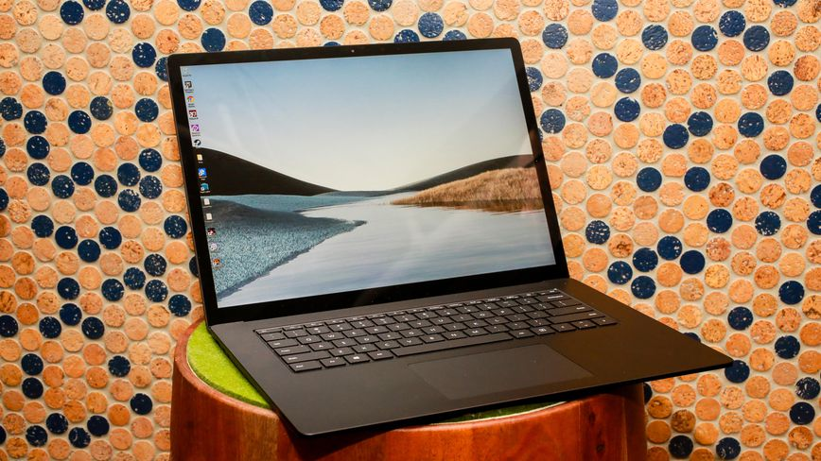

Price: $2000

**SPECIFICATIONS:**

|  |  |
| --- | --- |
| Processor: | Intel Core i5-1035G7 (1.2 GHz) |
| Memory: | 8 GB DDR4X |
| Storage: | 256 GB |
| Screen Size: | 13.5 |